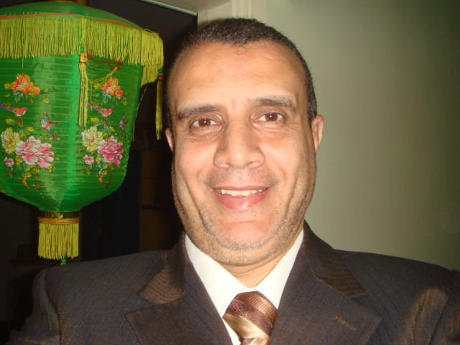Curriculum vitae

Name : Mustafa Thabet Hussein Mustafa
Date of birth : 27/04/1960
Place of birth : Assuit – Egypt
Address of correspondence : Assuit university hospital , radiology dept.
*Assuit. Egypt
Home 0020882291321
mobile 01122999878

* E –MAIL Thabet.mostafa.@yahoo0com
* Specialization : radiodiognosis
*Education:
- M.B.B.CH Assuit university, Sept. 1984
- Master degree of radio diagnosis Dec.1989(imaging study of abdominal swellings in children)
- MD of radiodiagnosis,jan.1996(bronchscopy and CT in diagnosis of bronchial tumors)
*courses:
- English language (britch council ) Nov.1994
- Computer course in MRI in Boston Medical center in USA, April 1998
- CPR-BLS Training from Saudi-American Association Of Heart Disease
- Training Of hospital administration and medical management IN ASSUIT UNVERSITY HOSPITAL
- Training in quality program
*Conferences :
Attended many conferences of Egyptian radiology society.(ESR) and in Saudi
*Graduation :
- House officer in Assuit University hospital from March 1985 to February 1986
- Resident in Radio diagnosis Department from March 1986 to February 1990
- Assistant lecturer of Radio diagnosis department from March 1990 to January 1996.
- Lecturer of Radio diagnosis from January 1996 to September 2002.
- Assistant professor of radio diagnosis since Sept.2002.
- Professor of radio diagnosis since

*Experiences :
- Conventional Radiography including contrast radiography and soft tissue (mammography)
- General and small parts ultrasonography (Breast, thyroid gland and scrotal)
- Trans-vaginal ultrasonography including follicomertry for ovulation monitoring.
- Scrotal and penile duplex U.S.
- Computed tomography for all parts including 3D and dynamic CT.
- MRI.
- Peripheral angiography.
- Imaging guided biopsy.
*researches in :
- 3D CT in Faciomaxillary trauma.
- Role of CT in abdominal lymphoma.
- High resolution CT in idiopathic pulmonary fibrosis.
- MRI of tempero-mandibular joint in rheumatic disease.
- Correlation of clinical , US , Doppler and isotopes scanning in thyroid disease.
- MRC in obstructive jaundice.
- MRI diffusion and perfusion of Ms
- US Vs CT and MRI in salivary gland disease
- Dynamic CT scan of pancreatic tumor
- MRI of perianal fisulae
- CT staging of rectal carcinoma.
- Embolization of splenic artery in hypersplenism
- Renal artery embolization in mamagment of renal artery pseudoaneurysem
- High resolution CT of facial nerve

El hamd lelah rab el almien
Thanks

Dr. Mustafa Thabet Hussian

